**Task 3: SQL for Data Analysis**

* **Setting-up the Environment in MySql**

**1. Database and Table creation as per data.csv structure**

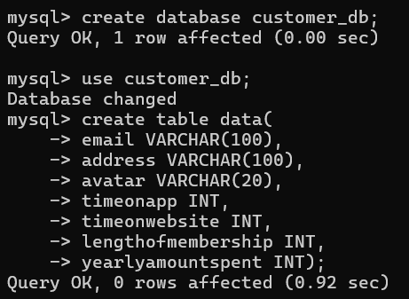

**2. Enable Local File Loading and exit**

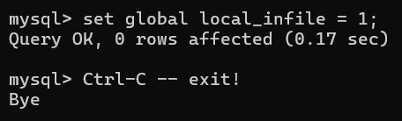

**3. Re-login with local file option and load the data**





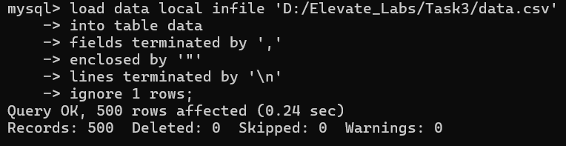

* **Start Analyzing the Data**

**1.Count of rows and maxing yearly amount spent**

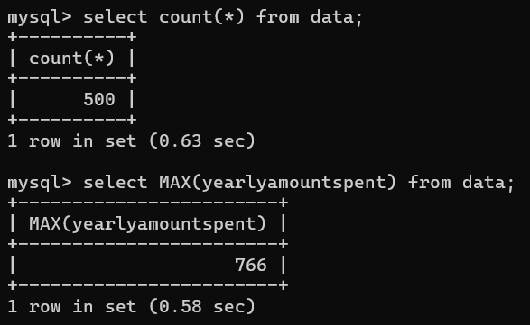

**2. Top 10 Customers by Yearly Spending**

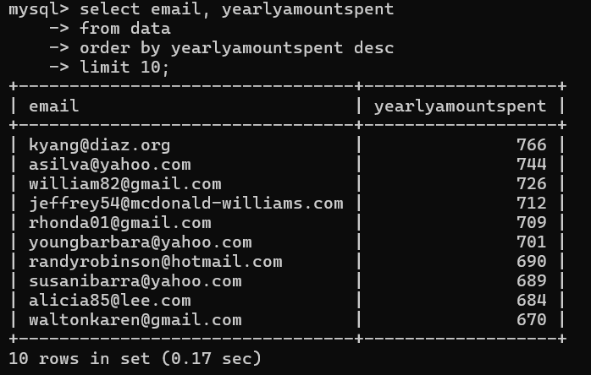

**3. Average Time on App vs Website**

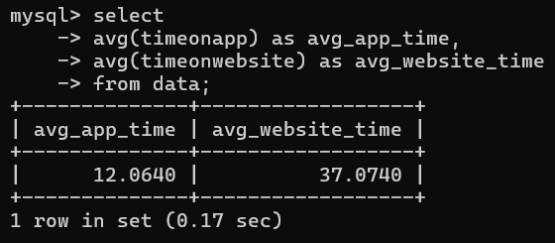

**4. Relationship Between Membership Length and Spending**

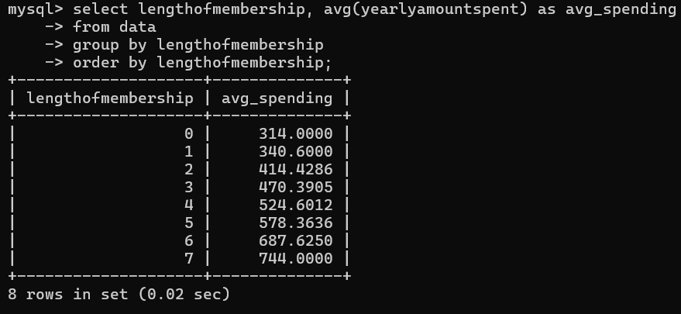

**5. Who Spends More: App Users or Website Users?**

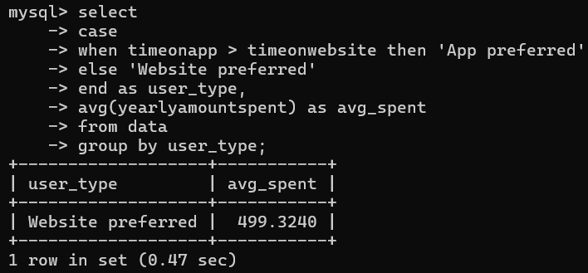

**6. Create a View for Ongoing Analysis**

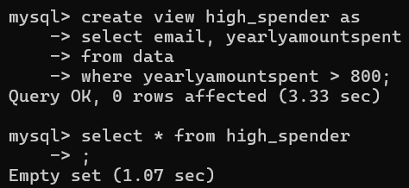

**7. Use a Subquery: Customers Above Average Spending**

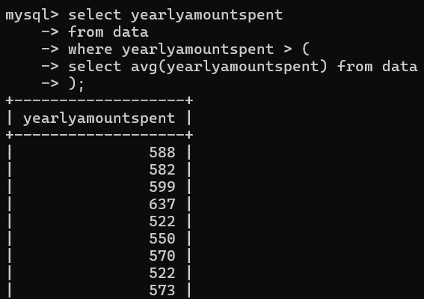

**8. Optimize Queries with Indexes**

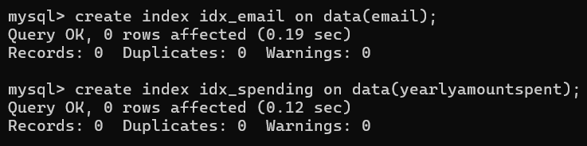

**9. Show full table**

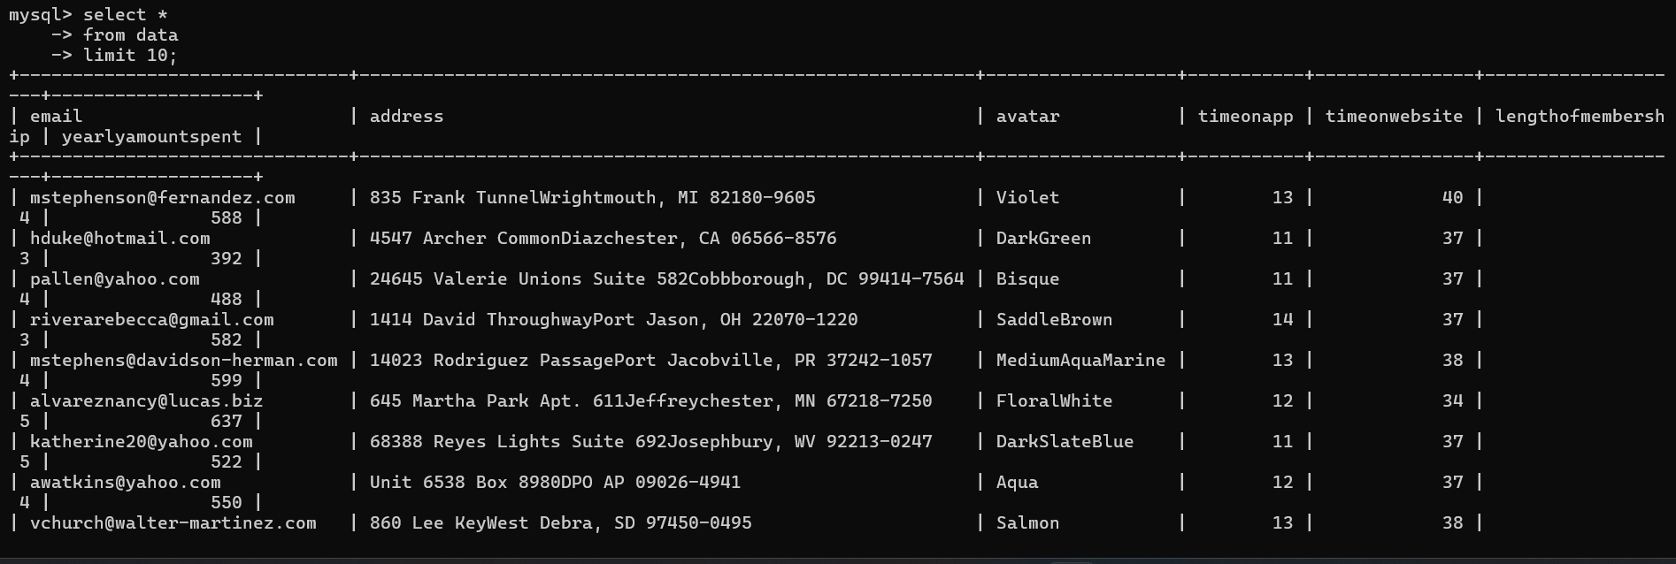

**10. Average time on app based on avatar**

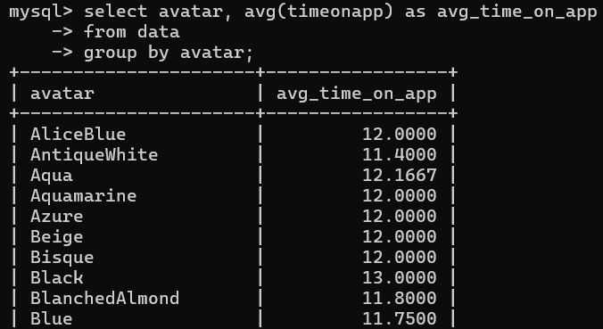

**11. Find the Most Engaged Users (High App + Website Time)**

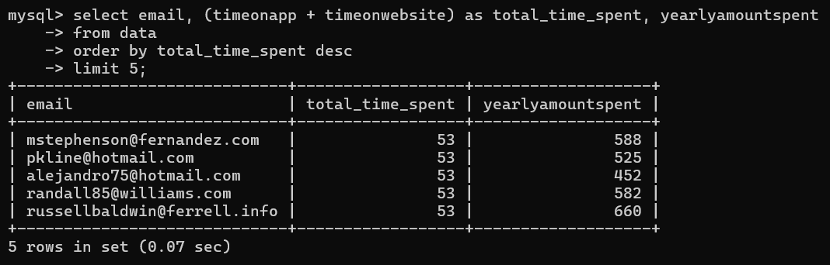

**12. Check If Longer Membership Correlates with More App Time**

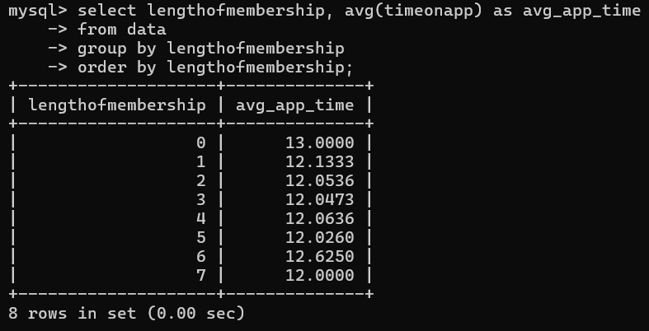

**13. Find Users Spending a Lot Despite Low Time on App**

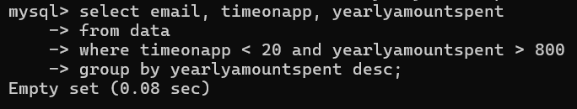

**14. Segment Users into Spending Buckets**

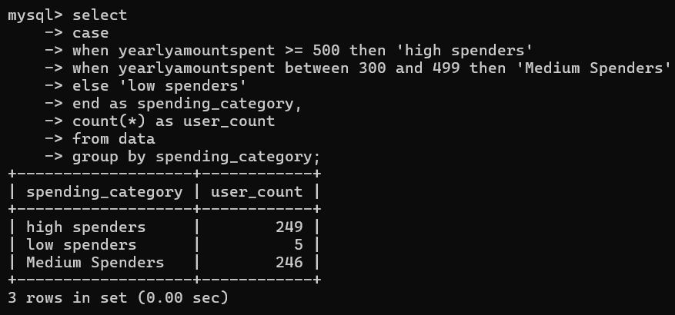

**15. Segment Users by Membership Duration**

